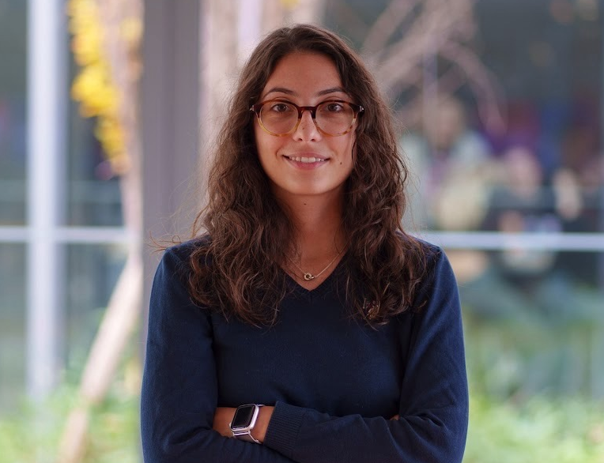
Giorgia Pisanu

Digital Management @ H-FARM College & Ca’ Foscari
giorgia.pisanu2005@gmail.com | +39 392 2752217
LinkedIn: giorgia-pisanu
Olbia, Sassari, Italy

Personal Profile
I’m a creative yet analytical student with strong problem-solving skills and a profound curiosity for technology and innovation. As a lifelong sportsperson, I’m naturally competitive and driven by challenges that push me beyond my comfort zone and my current capabilities. I’m extremely curious and a fast learner, constantly exploring new fields and adapting quickly to challenges that spark my curiosity. I thrive in collaborative environments where technology meets creativity, aiming to build solutions that create real-world impact.
Education
Bachelor of Science in Digital Management
H-FARM College for Ca’ Foscari University Venice, Expected Graduation: Summer 2027
- Activities: Business Consultant in the Junior Consulting Agency, LUMINA
- Relevant Coursework: Strategic and digital marketing, E-business, entrepreneurship and digital transformation, How to build an effective storytelling on Social Media
High School Scientific Diploma Grade: 100/100
Liceo Scientifico “L. Mossa” Applied Sciences - Olbia, Italy 2019 - 2024
Professional Experience
Summer Camp Media Residential Monitor
King’s College School - Cascais, Portugal 2025
- Managed a group of 80+ children aged 6-17, alongside 6 other instructors, designing and leading educational activities that promoted creativity and teamwork.
- Produced and managed daily social media camp content for @kingscollegeschool_cascais and parents blog viewed by over 10K users.
University Ambassador
H-FARM College - Roncade, Treviso, Italy 2024 - Present
- Represent the university in events, open days, and outreach activities, supporting prospective students and promoting the campus community.
- Strengthened communication, public speaking, and leadership skills through active participation in campus events.
Projects & Awards
Finalist - Giochi Matematici Nazionali, Bocconi University - Milan 2018
Reached the national finals among top Italian students in mathematical problem-solving and logical reasoning.
On the Wave
Founded a social media & branding agency helping local businesses enhance their digital presence. Developed brand identities and marketing strategies for clients as @Coffeekeys. Designed websites integrating storytelling and SEO optimization.
GuideMe - Travel Tech Startup Project
Developed and positioned a geo-localized travel app for an exam's project, that delivers personalized city routes and AI-generated audio storytelling by local experts. Led go-to-market strategy, user research, and brand positioning to enhance traveler engagement and cultural discovery.
NBA Data Analysis Project
Designed a data analytics project for the Coding exam, analyzing NBA player statistics using Python. Implemented object-oriented programming concepts through custom classes for structured data handling, integrating regression models, performance evaluation metrics, and data visualizations to enhance analytical efficiency.
Technical Skills
- Analytical: Market Research, KPI Measurement, User Insight, Google Analytics, SEO, Programming (Python, C++)
- Tools: Figma, Canva, ReadyMag, Wix, Shopify, VS Code, Google Ads, Excel (Intermediate)
- Certifications: Fundamentals of digital marketing (Google), Intr. to Neuromarketing (CBH - Coursera)
- Languages: Italian (bilingual), Romanian (bilingual), English (C1), Spanish (B2), Portuguese (exp. B1), French (A2)
Soft Skills
Proactivity • Flexibility • Critical Thinking Problem Solving • Creativity • Curiosity • Teamwork • Entrepreneurial Mindset

